A Mini Project Report

on

**Typing Speed Test**

**Course:** PP Lab

CLASS: B.E CSE-B Sem: II

By

**P VISHROTH REDDY**

**1602-21-733-134**

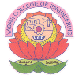

**Department of Computer Science & Engineering**

**Vasavi College of Engineering (Autonomous)**

**Ibrahimbagh, Hyderabad-31**

**2022**